Requirements and how to comply with the policy
- Ships, aircraft, and all other different transportation forms arriving from different counties will be required to have a valid yellow fever certificate showing that disinfection was done according to the rules and methods provide by the world health organization.
- The authorities will conduct further inspection to make sure that everyone is freed from this infection before granting permission to embark and disembark, entering the port, to load or discharge stores or cargo.
- Vaccines can improve public health dramatically, and any individual who fails to get vaccinated has an increase of spreading the infection to the entire community or his or her family, infants, and people that cannot get vaccinated due to the health medical conditions and friends.
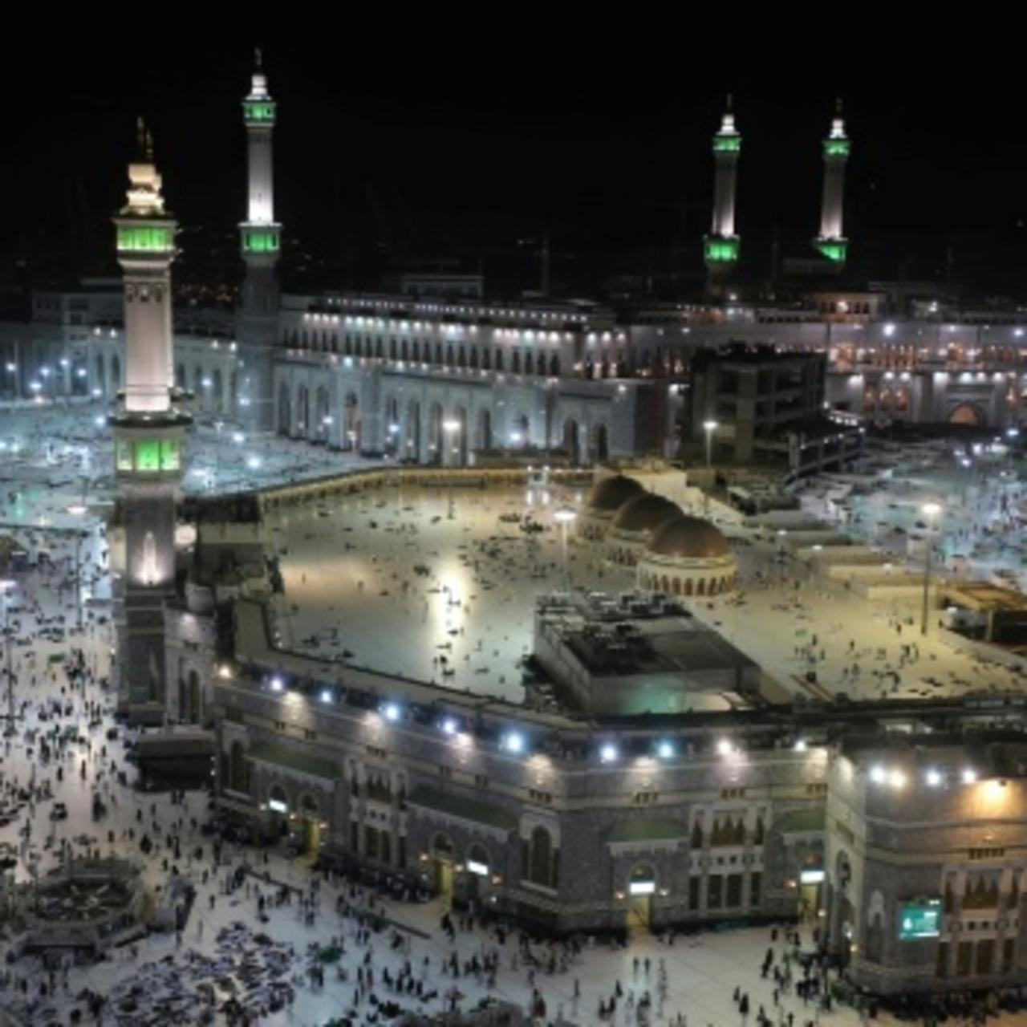
Vaccines required in Saudi Arabia
- Hepatitis A vaccine is also required for most of the travelers and Hepatitis B is a recommendation for health care workers and different Hajj participating caretakers.
- Up-to-date routine immunizations that include: mumps, measles, ACWY vaccine, diphtheria-tetanus-polio vaccine, and rubella (MMR) are advised and encouraged to all pilgrims. Polio, typhoid, influenza, meningitis, MMR, and hepatitis vaccines are recommended for Hajj.
- Some other different vaccines may be recommended depending on the private health history of someone.
- Proof for meningitis vaccination is also required for an entry during Hajj.
- The kingdom of Saudi Arabia’s ministry of health needs all people traveling from different countries or at a high risk of getting the yellow fever transmission to get tested and have a vaccination certificate.
- The yellow fever vaccine certificate is only valid for life commencing ten days after the vaccination process and period.
- Failure to all this, the KSA Ministry of Health denies entry to this kingdom and fails to issue Hajj or Umrah visas.
- Children and pregnant women are also not advised to travel ad if they must, they should receive meningococcal vaccination which requires their age-licensed indications.
- The goal of vaccinating against infectious diseases is to: Saves $33.4 billion in indirect costs, prevent 14 million cases of the disease, saves 33,000 lives, and Reduces direct health care costs by $9.9 billion.
Saudi Arabia traveling requirements
This information is to let all the international travelers know the different recommendations and requirements for any person entering into Saudi Arabia for Hajj and Umrah as put in place and provided by the authorities from the Saudi health team.
A vaccination proof is required b KSA as a part of Visa application for the Haj and Umrah. Saudi Arabia should also familiarize themselves with decency laws that require individuals which include both males and females to dress modestly by having their knees and shoulder covered, tight-fitting clothes should be avoided, and profane images or language clothes.
The vaccines required include meningitis and for all people coming from countries affected by the yellow fever pandemic.
The countries which are at a high risk of getting infected with Yellow Fever according to the World Health organization Health guidelines and international travel include:
South and Central American States: Guyana, Argentina, Colombia, the Bolivarian Republic of Venezuela, French Guiana, Panama, Brazil, Ecuador, Bolivia, Paraguay, Tobago, Surinam, and Trinidad.
African states: Ethiopia, Gabon, Gambia, Ghana, Guinea, Guinea-Bissau, Kenya, Liberia, Mali,
Mauritania, Niger, Nigeria, Senegal, Sierra Leone, Sudan, the Republic of South Sudan,
Togo, Uganda, Angola, Benin, Burkina Faso, Burundi, Cameroon, the Central African
Republic, Chad, Congo, Côte d'Ivoire, the Democratic Republic of the Congo, and Equatorial Guinea.

